Obstacles:

1. Brandwatch query result not including instagram.com
2. Lego followers/community members demographic breakdown

Demographics for Instagram:

Source: <https://blog.hootsuite.com/instagram-demographics/>

* Age:

13-17 years old: 8.5%

18-24 years old: 30.1%

25-34 years old: 31.5%

35-44 years old: 16.1%

45-54 years old: 8%

55-64 years old: 3.6%

65 years old and up: 2.1%

As of 2022, the majority of Instagram’s audience are Millennial or Gen Z users.

* Gender:

The balance of male to female users is fairly evenly split, with total male users (50.7%) edging out total female users (49.3%) by just a hair.

* Income:

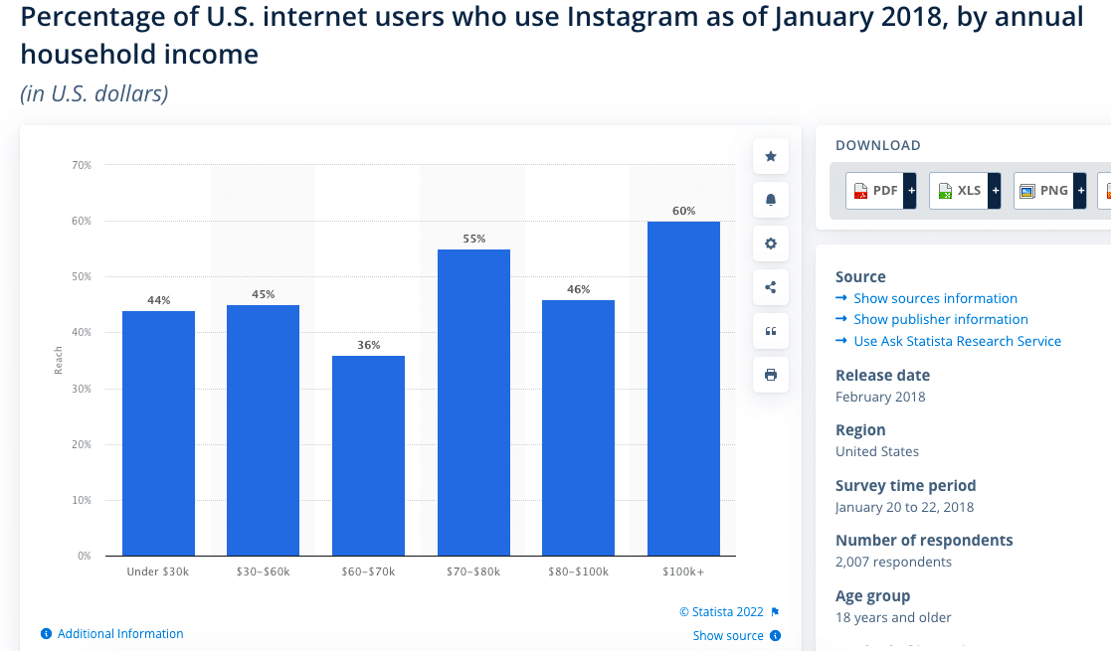

* Education: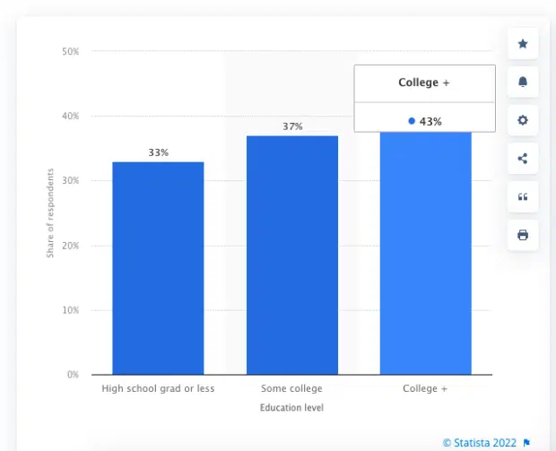

Tips to increase instagram engagement:

1. [Post consistently.](https://www.brandwatch.com/blog/tips-increase-instagram-engagement/#section-2)
2. [Don’t preach—tell stories instead.](https://www.brandwatch.com/blog/tips-increase-instagram-engagement/#section-7)
3. [Build a strong brand.](https://www.brandwatch.com/blog/tips-increase-instagram-engagement/#section-10)
4. [Have a visually consistent feed.](https://www.brandwatch.com/blog/tips-increase-instagram-engagement/#section-11)
5. [Choose the right hashtags.](https://www.brandwatch.com/blog/tips-increase-instagram-engagement/#section-16)
6. [Focus on user-generated content.](https://www.brandwatch.com/blog/tips-increase-instagram-engagement/#section-20)
7. [Explore the full range of Instagram video formats.](https://www.brandwatch.com/blog/tips-increase-instagram-engagement/#section-23)
8. [Use Instagram video subtitles and closed captions.](https://www.brandwatch.com/blog/tips-increase-instagram-engagement/#section-26)
9. [Activate Instagram Reels.](https://www.brandwatch.com/blog/tips-increase-instagram-engagement/#section-27)
10. [Embrace Instagram AR filters.](https://www.brandwatch.com/blog/tips-increase-instagram-engagement/#section-32)
11. [Take advantage of Instagram’s video ad formats.](https://www.brandwatch.com/blog/tips-increase-instagram-engagement/#section-35)
12. [Give Gifs a chance.](https://www.brandwatch.com/blog/tips-increase-instagram-engagement/#section-36)
13. [Use Instagram traffic to increase website traffic.](https://www.brandwatch.com/blog/tips-increase-instagram-engagement/#section-37)
14. [Use SEO to ‘win’ Instagram.](https://www.brandwatch.com/blog/tips-increase-instagram-engagement/#section-38)
15. [Partner with micro-influencers to create brand authenticity.](https://www.brandwatch.com/blog/tips-increase-instagram-engagement/#section-41)
16. [Host an Instagram contest.](https://www.brandwatch.com/blog/tips-increase-instagram-engagement/#section-44)
17. [Convert Instagram followers into email subscribers.](https://www.brandwatch.com/blog/tips-increase-instagram-engagement/#section-47)
18. [Embrace Instagram Stories.](https://www.brandwatch.com/blog/tips-increase-instagram-engagement/#section-48)
19. [Add a link to Instagram Stories.](https://www.brandwatch.com/blog/tips-increase-instagram-engagement/#section-50)
20. [Use emojis effectively.](https://www.brandwatch.com/blog/tips-increase-instagram-engagement/#section-51)
21. [Promote your Instagram channel on other social accounts.](https://www.brandwatch.com/blog/tips-increase-instagram-engagement/#section-52)
22. [Add CTAs, everywhere.](https://www.brandwatch.com/blog/tips-increase-instagram-engagement/#section-53)
23. [Track and learn from your best-performing Instagram content.](https://www.brandwatch.com/blog/tips-increase-instagram-engagement/#section-54)

Lego Twtter vs. Instagram:

<https://www.brandwatch.com/blog/the-online-world-of-lego/>